

Year 10 HASS - Task 4 (Weighting – 8%)
My Target: ____ / 46 or _____%
(History – In-class Responses)
In-class Test – Test, timed conditions

46
Time: 5 minutes – reading time and 50 minutes working time

NAME:_______________________Teacher:_________________________

SECTION ONE: Multiple Choice (13 marks)

1. The formation of the United Nations (UN) was a direct result of which conflict?

- The First World War.
- The Great War.
- World War I.
- World War II.

2. The UN followed a similar organisation that had been formed 26 years earlier. This was known as:
- The Union of Nations.
- The League of Nations.
- The United League.
- The League of United Nations.

3. What important document was adopted by the UN on 10 December 1948?
(a) The Mabo Decision.
- The Universal Declaration of Human Rights.
- The surrender of all German forces during the Second World War.
- The Universal Declaration of non- nuclear proliferation.

11. How many articles are present within the Universal Declaration of Human Rights?

- 20
- 30
- 60
- 32

5. The United Nations (UN) was formed in

(a) 1918
- 1946
(c) 1945
(d) 1919

SECTION TWO: Short Responses/Source Analysis (25 marks)

- Define the following term and provide an example to support your definition.

(3 marks)

________________________________________________________________

________________________________________________________________

________________________________________________________________

________________________________________________________________

________________________________________________________________

________________________________________________________________

PART B: Source Analysis

The following questions relate to Source 1. You must refer to Source 1 to address the following questions.

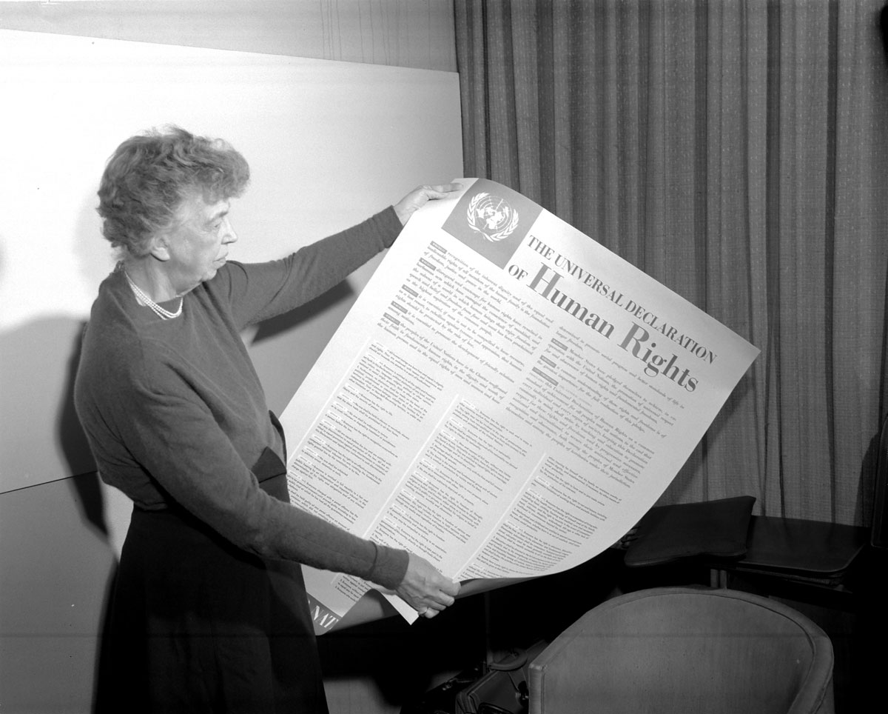
Source 1

Source 1: Website Name – The ABC,

http://www.abc.net.au/radionational/programs/latenightlive/revoking-citizenship-without-process-runs-counter-magna-carta/6546824 Date accessed: 1/5/2016

1. State if Source 1 is a primary or secondary source. (1 mark)

__________________________________________________

2a. Look at Source 1; state the name of the person shown in the photograph.

_____________________________________________ (1 mark)

2b. Look at Source 1; state the full name of the documents the person is holding. Use correct spelling.

___________________________________________________ (2 marks)

2c. State the full date (date, month, year) the document from part 2b was adopted.

____________________________________________________ (3 marks)

3. With reference to Source 1, outline which international organisation adopted the document. (3 marks)

__________________________________________________________________________________________________________________________________________________________________________________________________________________________________________________________________________________________________________________________________________________________________________________________________________________________________________________

4. With reference to Source 1, outline why this document was created and the purpose of the document being held in the photograph. (3 marks)

__________________________________________________________________________________________________________________________________________________________________________________________

__________________________________________________________________________________________________________________________________________________________________________________________

__________________________________________________________________________

__________________________________________________________________________

__________________________________________________________________________

__________________________________________________________________________

PART C: Validation Questions (8 marks)

Select an event from below
- The Kokoda Track Campaign
- The Fall of Singapore
- The Battle of Britain
- The Battle of Alahaim

Explain the significance and the causes and effects of a key historical event you have selected from the list above.

Note: A good answer will incorporate clear and concise supporting evidence, such as data, statistics and examples.

__________________________________________________________________________

__________________________________________________________________________

__________________________________________________________________________

__________________________________________________________________________

__________________________________________________________________________

__________________________________________________________________________

__________________________________________________________________________

__________________________________________________________________________

__________________________________________________________________________

__________________________________________________________________________

__________________________________________________________________________

__________________________________________________________________________

__________________________________________________________________________

__________________________________________________________________________

__________________________________________________________________________

__________________________________________________________________________

__________________________________________________________________________

__________________________________________________________________________

__________________________________________________________________________

__________________________________________________________________________

__________________________________________________________________________

__________________________________________________________________________

__________________________________________________________________________

__________________________________________________________________________

__________________________________________________________________________

__________________________________________________________________________

__________________________________________________________________________

__________________________________________________________________________

__________________________________________________________________________

__________________________________________________________________________

__________________________________________________________________________

__________________________________________________________________________

__________________________________________________________________________

__________________________________________________________________________

__________________________________________________________________________

__________________________________________________________________________

__________________________________________________________________________

__________________________________________________________________________

__________________________________________________________________________

__________________________________________________________________________

__________________________________________________________________________

__________________________________________________________________________

__________________________________________________________________________

__________________________________________________________________________

__________________________________________________________________________

__________________________________________________________________________

__________________________________________________________________________

__________________________________________________________________________

End of test paper

